# Homework #1: Windows Server 2016 VM creation and the installation of SQL Server 2016

|  |
| --- |
| * This is an individual assignment, and is worth 20 points. Specifically, for this assignment, you can submit your outcome after the due date until January 24th. However, you will get 50% of the allowed maximum point. * The due date is 11:00 (sec 02) / 5:30 (sec 76) on Thur, 1/17. * You should use the “CIS 483 Homework #1 VM Creation-Tasks.docx” file to provide your answers. * Use the following naming convention: homework, underscore, last name, first initial, and extension (e.g., Homework #1_ImG.docx). If you do not follow the convention, I will deduct 1.0. * Do not copy any of the sample screenshots provided as illustrations. * I may waive a penalty when you report any technical issues before the due date. |

**(TASK #1: 5 points)** Login to the Windows Server, and take a screenshot of the first screen.

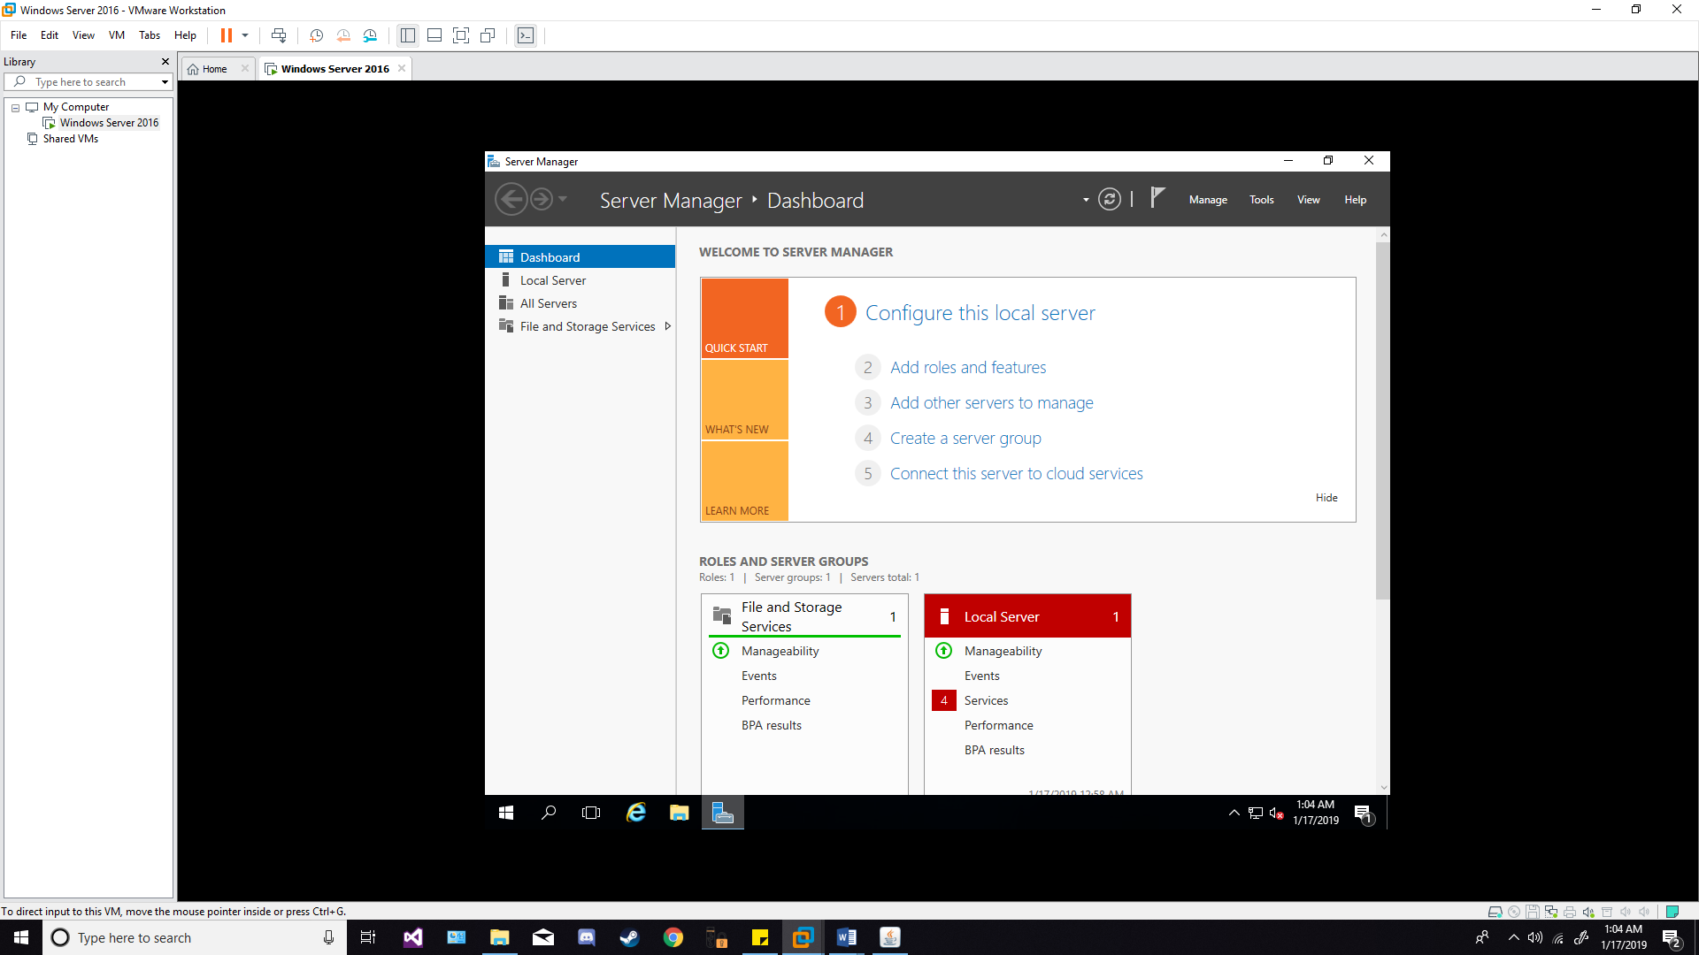

**(TASK #2: 5 points)** Run the following queries. Show the results in a screenshot. You must show that the installation is SQL Server 2016 Standard.

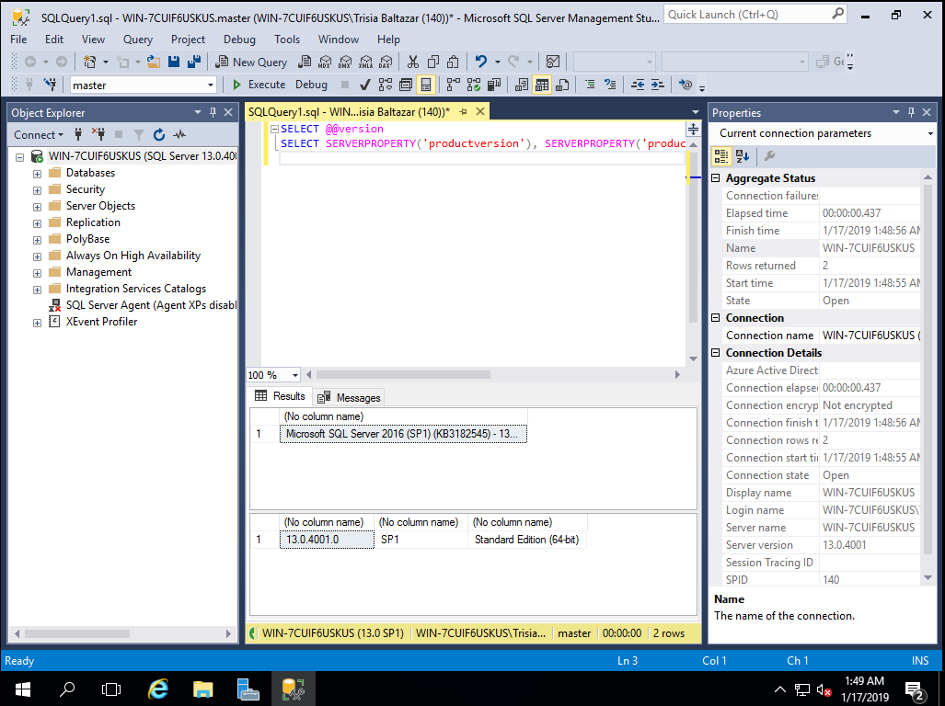

**(TASK #3: 5 points)** Show in a screenshot that the services you have installed are running.

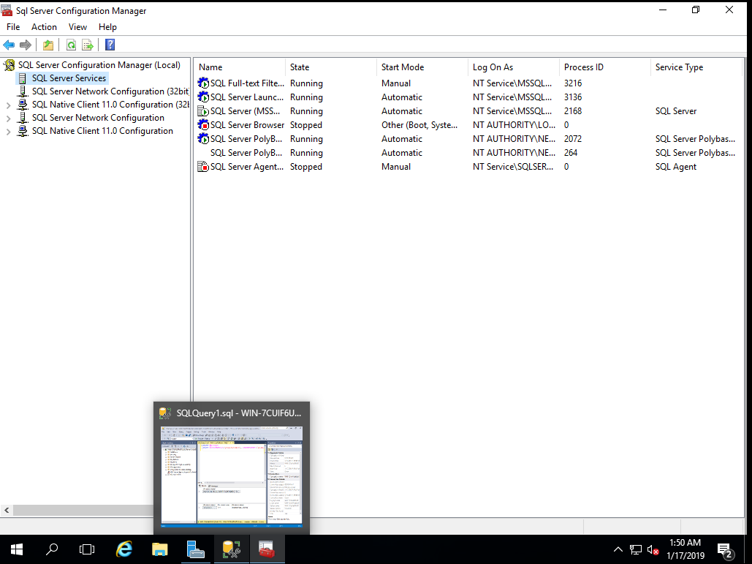

**(TASK #4: 5 points)** Execute the following query. Show the result in a screenshot.

